Feature Crosses

A **feature cross** is a **synthetic feature** formed by multiplying (crossing) two or more features. Crossing combinations of features can provide predictive abilities beyond what those features can provide individually.

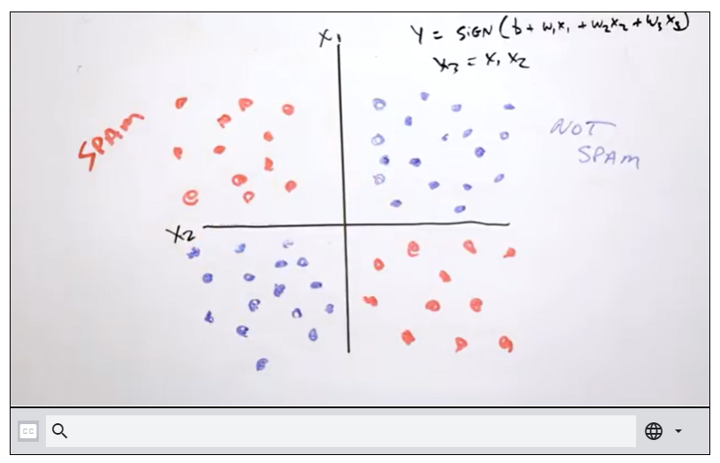



## **Feature Crosses: Some Examples**

* **Housing market price predictor:**

[latitude X num_bedrooms]

* **Tic-Tac-Toe predictor:**

[pos1 x pos2 x ... x pos9]

### **Kinds of feature crosses**

We can create many different kinds of feature crosses. For example:

* [A X B]: a feature cross formed by multiplying the values of two features.
* [A x B x C x D x E]: a feature cross formed by multiplying the values of five features.
* [A x A]: a feature cross formed by squaring a single feature.

Thanks to [stochastic gradient descent](https://developers.google.com/machine-learning/crash-course/reducing-loss/stochastic-gradient-descent), linear models can be trained efficiently. Consequently, supplementing scaled linear models with feature crosses has traditionally been an efficient way to train on massive-scale data sets.

# Crossing One-Hot Vectors

So far, we've focused on feature-crossing two individual floating-point features. In practice, machine learning models seldom cross continuous features. However, machine learning models do frequently cross one-hot feature vectors. Think of feature crosses of one-hot feature vectors as logical conjunctions. For example, suppose we have two features: country and language. A one-hot encoding of each generates vectors with binary features that can be interpreted as country=USA, country=France or language=English, language=Spanish. Then, if you do a feature cross of these one-hot encodings, you get binary features that can be interpreted as logical conjunctions, such as:

  country:usa AND language:spanish

As another example, suppose you bin latitude and longitude, producing separate one-hot five-element feature vectors. For instance, a given latitude and longitude could be represented as follows:

binned_latitude = [0, 0, 0, 1, 0]

binned_longitude = [0, 1, 0, 0, 0]

Suppose you create a feature cross of these two feature vectors:

binned_latitude X binned_longitude

This feature cross is a 25-element one-hot vector (24 zeroes and 1 one). The single 1 in the cross identifies a particular conjunction of latitude and longitude. Your model can then learn particular associations about that conjunction.

Suppose we bin latitude and longitude much more coarsely, as follows:

binned_latitude(lat) = [

0 < lat <= 10

10 < lat <= 20

20 < lat <= 30

]

binned_longitude(lon) = [

0 < lon <= 15

15 < lon <= 30

]

Creating a feature cross of those coarse bins leads to synthetic feature having the following meanings:

binned_latitude_X_longitude(lat, lon) = [

0 < lat <= 10 AND 0 < lon <= 15

0 < lat <= 10 AND 15 < lon <= 30

10 < lat <= 20 AND 0 < lon <= 15

10 < lat <= 20 AND 15 < lon <= 30

20 < lat <= 30 AND 0 < lon <= 15

20 < lat <= 30 AND 15 < lon <= 30

]

Now suppose our model needs to predict how satisfied dog owners will be with dogs based on two features:

* Behavior type (barking, crying, snuggling, etc.)
* Time of day

If we build a feature cross from both these features:

[behavior type X time of day]

then we'll end up with vastly more predictive ability than either feature on its own. For example, if a dog cries (happily) at 5:00 pm when the owner returns from work will likely be a great positive predictor of owner satisfaction. Crying (miserably, perhaps) at 3:00 am when the owner was sleeping soundly will likely be a strong negative predictor of owner satisfaction.

Linear learners scale well to massive data. Using feature crosses on massive data sets is one efficient strategy for learning highly complex models. [Neural networks](https://developers.google.com/machine-learning/crash-course/introduction-to-neural-networks) provide another strategy.